Year 10 : Media Studies : Science Fiction Posters:
Guidance Booklet
Task
• a production exercise (40 marks) linked to the assignment
• an evaluative commentary (20 marks) on the planning process and the production exercise, together with evidence of planning.

Therefore it is important that centres set exercises that enable their candidates to demonstrate their understanding of the media key concepts
of Representation and Media Language. Centres are expected to use the technical resources available to them, including the use of digital media. The use of original photography is strongly encouraged

As guidance, the commentary should be around 350–750 words in length; or 5–10 slides if using a PowerPoint style presentation; or around three minutes for a podcast.
In the commentary, the following areas must be covered in whatever form the candidate has chosen:
• an account of the research and planning carried out
• how the production is targeted at a particular target audience
• an explanation of the ways in which media language has been used in the production exercise to communicate representation
• an explanation of the ways in which codes and conventions have been used in the production exercise to communicate representation
• an evaluation of the strengths /weaknesses within the finished production.

Mark scheme for the posters

Level 4 (31–40 marks)
An excellent response to the task that demonstrates:
• excellent organisation and presentational skills in the chosen medium
• excellent understanding of the media language that has been used to construct representation
• excellent understanding of the generic codes and conventions that have been used to construct representation
• excellent sense of creativity and stimulation employed in targeting a specific audience

Level 3 (21-30 marks) as above but replace excellent with proficient
Level 2 (11-20 marks) as above but replace proficient with basic.
Level 1 (1-10 marks) as above but replace basic with minimal.

For the powerpoint (planning and evaluation)

Level 4 (16–20 marks)
.There is excellent research into similar media texts.
• There is excellent planning, with clear evidence of organised use of time.
• There is excellent reference to the ways the production is aimed at a target audience.
• There is an excellent understanding of the ways in which media language has been used to construct representation.
• There is an excellent understanding of the ways in which generic codes and conventions have been used to construct representation
• The evaluation is excellent, with a clear sense of reflection on the work.
• There is an accurate command of medium-specific terminology

Level 3 (11-15 marks) as above but replace excellent with proficient
Level 2 (6-10 marks) as above but replace proficient with basic.
Level 1 (1-5 marks) as above but replace basic with minimal.

Keywords
genre
conventions
representations
ideology
audience expectations
dystopian
utopian
binary opposites
protagonist
antagonist
uniformity/ individuality
totalitarian
Institutional Context
Shot Composition
Colour Scheme
Genre
Connotations
Anchorage
iconography
representations
tagline
Uses and Gratification
USP
persuasion and persuasive language
certification
release date
branding and marketing
the rule of thirds

Research - analysis of posters / analysis of genre conventions

Your powerpoint should have analysed a range of posters for the genre indicating some of the key narrative and design conventions that you have noticed.

Teaser poster - This poster contains basic information to whet your appetite. It often does not indicate much about the plot, but may have a picture of the stars, and the name of the film.
Main theatrical poster - This contains information about the production personnel, the stars, and the distributors.

q1 What do you notice about the representation of places and setting?
q2. Which colour design is conventional in this genre?
q3. Which slogans worked best and why?
q4. Why have particular text types and fonts been chosen?
q5. What information is required on the poster for a theatrical release?
q6. How are images used to tell the story?
q7. How does shot composition make clear which characters are most important or powerful?
q8. Which conventions of dystopian SF do these posters remind you of? (think about common representations of societies and problems that societies in the future will face)
q9. How do costume and body language create character representations?(of antagonists and protagonists)
q9. Which posters did you find most effective and why?

EXAMPLE ANALYSIS : STAR WARS POSTER
This is a complicated poster which illustrates a great deal about the narrative/story in order to create interest in the film and reinforce the genre. Luke is the main protagonist and is central to the image. Shot composition tells us a great deal about characters and creates immediate representations. Luke is central and his image takes up more of the space on the poster. His pose is determined and he is the only character looking directly at the audience. He is flanked by other protagonists (Han and Leia) , both firing weapons indicating the action in the film's narrative. Secondary characters (R2D2, Ben) are given less space. We also note Darth Vader in the background of the image. Although backgrounded there is a forced perspective and he is given similar space to the protagonists connoting his importance to the narrative as a constant threat.
Clothing and costume create clear representations. Luke's robes and lightsabre have connotations of medieval knights while Han's holster and waistcoat create connotations of the cowboy. As the knight and cowboy are stereotypically represented as heroic this creates further positive connotations. Darth Vader's Mechanical costume dehumanises the character and positions the audience to see him as an antagonist. This is reinforced by the colour connotations of Luke's white and Vader's black costumes. The characters are well lit, while the two characters with more low key lighting are Han (possibly connoting his anti-hero status) and Peter Cushing playing a high ranking antagonist. The characters are flanked by battling spaceships to reinforce the theme of action. Around the characters there is a background of stars in space which clearly indicates the science fiction genre. The dominant colour is blue, a cold colour which is conventionally used in the genre. The Death Star is featured at the top left. Like Vader, its position indicates threat and is conventional to the genre suggests a technological threat.
A white banner at the bottom of the poster has key information such as the name of the film and film companies.Actors are listed in order of status (Ford was yet to become a major star) followed by the director, producer and composer. The Film name has a different font and is enlarged to improve marketing potential.

Planning Your Posters – Drafts

Teaser poster[edit]
A teaser poster or advance poster is an early promotional film poster, containing a basic image or design without revealing too much information such as the plot, theme, and characters. The purpose is to incite awareness and generate hype for the film. A tagline may be included. There are some instances when teaser posters are issued long in advance before the film goes into production (teasers for cancelled projects are historically informative), although they are issued during the film development. Notable styles for teaser poster include:
- Bearing only a symbol associated with the film, or simply just the title.
- A main character, looking away from the screen but looking at something in the distance.

Character posters
For a film with an ensemble cast there may be a set of character posters, each featuring an individual character from the film. Usually it contains the name of the actor or the name of the character played. It may also include a tagline that reflects the quality of the character.

Teaser or Character Poster
Try to think of images that are symbolic of key concepts such as indiduality/uniformity, freedom/oppression.
Think of an image and slogan that will create enigma.
Where will you place objects and characters in the image?
How will colour design, setting and font reinforce genre and antagonists / /protagonists? (representation of character types)
What representations are you creating? (e.g of dystopian societies crushing individuality) (powerful and resourceful heroes or sinister antagonists, sidekicks or damsels in distress)

Theatrical poster
Which antagonists and protagonists will you feature?
How will you represent them?
What fonts will you choose and why?
What slogan/reviews/taglines will you feature?
What colour design/lighting/sets/costumes will you feature?
Which camera angles will you feature?
How will you position characters in the shot?

Key Representations to Consider
- Heroic protagonist seeking to overthrow a corrupt government.
- Protagonists who are clearly individuals as opposed to uniform antagonists.
- Corrupt government seeking to eliminate individuality.
- A world controlled by machines or a world threatened by takeover from machines.
- A future world with an enormous divide between rich and poor and a totalitarian government.
- A world in which the environment has been destroyed and individuals are struggling to survive.

Information to include on the bottom of your theatrical poster.

Film Company
Director
Actors
Producer
Music
Editor
Production Design
Director of Photography
Screenplay
Distribution Company

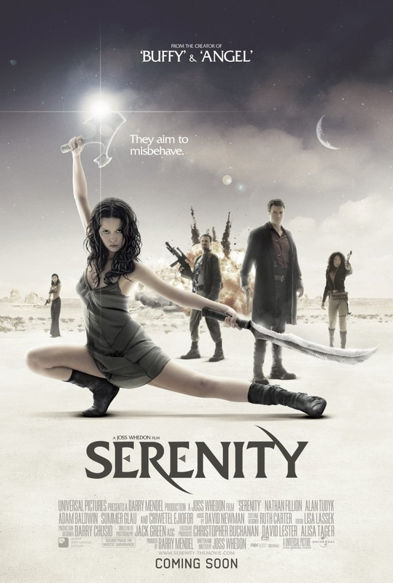

Student Examples
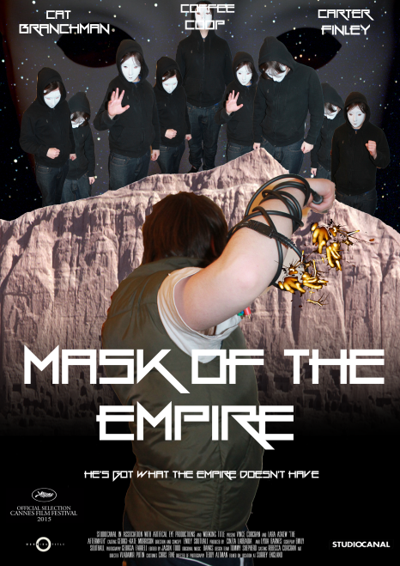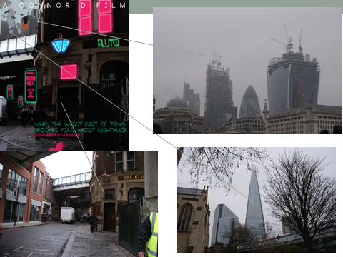

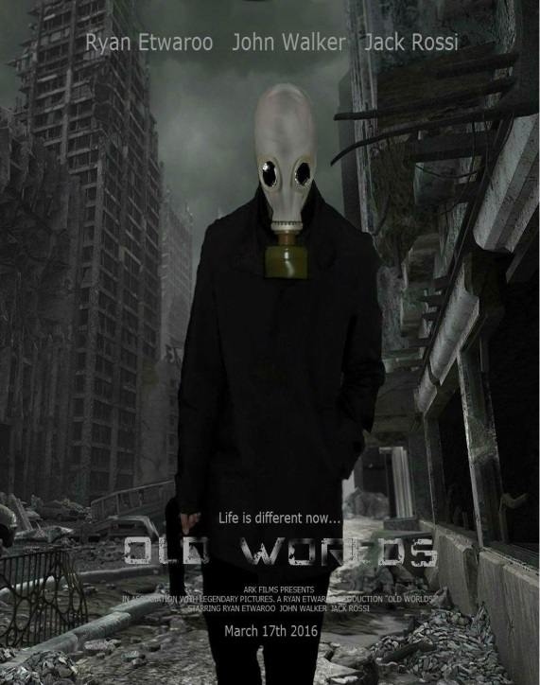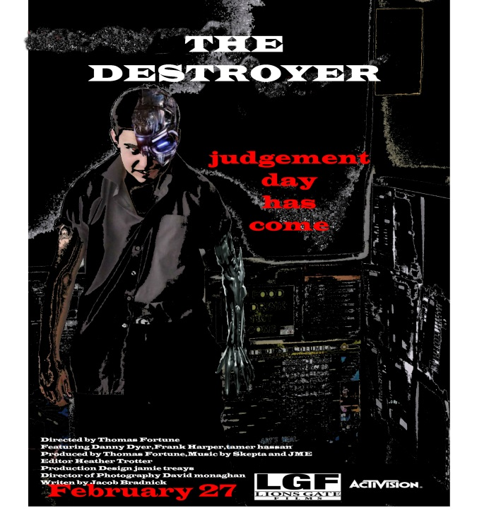

Planning and Evaluation Checklist (Do you have these in your powerpoint?)
Poster Drafts
Analyses of other posters
Evidence of your I.T skills
Clear explanation of your representations (e.g of protagonists/antagonists/society)
Have you evaluated the success of your posters in the same way as you evaluated/analysed other posters?

