GCSE Media Studies
Revision Pack

Contents:
Section A – Action/Adventure Films
- Terminology Glossary
- What is Section A about?
- Action/Adventure Conventions Revision
- Superman Returns screenshot analysis
- Action/Adventure Representation Revision
- Representation screenshot analysis
Section B – TV Comedy
- Terminology Glossary
- What is Section B about?
- Audience Pleasures in TV Comedy Revision
- Institution and scheduling Revision
Practice Exam Papers
1. Practice Questions
2. Example Answers

Glossary of Moving-Image Terminology
Terminology | What it means...
Editing
Continuity editing | The system of cutting used in most mainstream films. The intention is to establish the illusion of continuous action and keep the audiences’ attention on the story.
Non-continuity editing | Use of editing style which draws the audience attention to the film making process to reveal that film is ‘constructed’, not ‘natural’.
Shot-reverse-shot | This is when one character is shown looking at another character (often off-screen), and then the other character is shown looking "back" at the first character.
Cross-cutting | Cross-cutting is an editing technique most often used in films to establish action occurring at the same time in two different locations. In a cross-cut, the camera will cut away from one action to another action, which can suggest the simultaneity of these two actions but this is not always the case.  It can be used to build suspense.
Fast-paced editing | When scenes are edited together using lots of shots cut together quickly. Has the effect the action is taking place quickly and can build tension.
Dissolve | The gradual transition from one image to another.
Cut | An abrupt transition from one shot to another. Usually it is used to maintain continuity editing.
Wipe | A transition from one image to another. One image is replaced by another with a distinct edge that forms a shape. For example a simple edge, an expanding circle, or the turning of a page. Makes the audience more ‘aware’ they are watching a film.
Fade | Transition generally used at the end of a scene to signify to the audience an end of action. Generally action will fade to black.
Jump cut | Two shots of the same subject are taken from camera positions that vary only slightly. It causes the subject to appear to ‘jump’ in an abrupt way, drawing the audiences’ attention to the editing.
CGI | Computer generated imagery. Any still or moving image created using software.
Slow motion | A post-production effect in which time seems to slow down.

Camera
Establishing shot | A shot which establishes the setting for the scene. For example: A long shot of a building exterior.
Ariel shot | Sometimes called a ‘bird’s eye view’. This is an extreme high-angle shot.
Point-of-view shot | A shot intended to show the action from the perspective of a particular character.
Hand-held camera | A shaky effect created when the cinematographer just holds the camera. Has the effect of the audience feeling as if they are ‘in’ the action.
Steadicam | Used to achieve a smooth even shot when shooting action.
Crane shot | A shot created using a large camera mounting, capable of achieving high elevations and movements.
Tracking shot | A shot in which the camera moves to follow a sequence of action, placed usually on a dolly or specially prepared tracks.
Shallow Focus | Part of the image is in focus while the rest is out of focus or blurred. This draws the audiences’ attention to a particular action/character.
Canted Angle (or Dutch Angle) | The camera is placed on a slant. Often used to portray the psychological uneasiness or tension in the subject being filmed.
Dolly Zoom | A cinematic technique in which the camera moves closer or further from the subject while at the same time adjusting the zoom to keep the subject the same size in the frame. The effect is that the subject appears stationary while the background size changes.
Sound
Diegetic sound | Sound which has a source on-screen. For example: dialogue.
Non-diegetic sound | Sound which does not have a source on-screen. For example: music or voiceover.
Sound bridge | The sound from one scene continuing to the next or the sound from the next scene being used before the audience see the relevant images. It gives the sense that the film is ‘linked’ together.
Synchronous sound | Sounds which are expected with what is viewed. For example in a birthday party you expect to hear laughter, singing and music
Asynchronous sound | Sound which does not match or is unexpected with the images on the screen. Can be used to build tension, suspense or emotion.
Voiceover | Non-diegetic sound of a person speaking over a scene.

General
Connotation/connotates | What you associate with an image or the deeper or hidden meanings and associations. For example: The use of a spaceship set, green lighting and make-up which makes the actors look like aliens connotates to the audience that this is a science-fiction film.
Signify/signifies | The associations that a sign or symbol refers to. For example: The antagonist has a gun which signifies he is violent.
Convention | A common sets of standards used to make texts easily identifiable.
Mise-en-scene | What is placed in a scene. This may include setting, lighting, spatial relationships between actors, casting, costume, make-up and props.
Hybrid Genre | When the films could be categorised as more than one film genre. For example an action/adventure comedy or an action/adventure sci-fi.
Protagonist | The hero
Antagonist | The villain

What is Section A about?
Section A includes assesses your textual analysis skills. In the exam you will watch a short extract from an action/adventure film (around 6 minutes long) four times and will then be expected to answer three questions about the extract.
Question 1 – will ask you how the extract you have just seen fits the codes and conventions of action/adventure in general. These are some of the points you could include if asked about how the characters and/or events are conventional:
REMEMBER – you need to use examples from the extract to support your point:
- The protagonist is brave in the face of danger and will often (but not always) easily beat the antagonists even when outnumbered.
- The protagonist is resourceful and clever
- The protagonists are attractive and youthful when compared with the antagonists.
- The antagonists are violent and intimidating (could be seen through their costumes or props).
- There is a clear theme of good vs. evil
- Conflict is resolved through violence.
It is possible the extract may NOT be typical in places. This needs to be mentioned.
Question 2 – will ask you to analyse how the camera, editing, soundtrack and mise-en-scene are used in the extract to create a particular effect which fits the action/adventure genre. You will be expected to give direct examples from the extract and explain the connotative effect your examples have on the audience. You should also link back to action/adventure conventions.
Question 3 will ask you to show your understanding of issues of representation used within the extract. You may be asked to consider any of the following are represented:
- Gender
- Ethnicity
- Sexuality
- Age
- Disability
- War
- Authority
- Etc...
In your answer you should:
- identify your examples
- describe the representations of the named area (e.g. ethnicity)
- describe the messages and values in these representations
- Shown your wider understanding of issues of representation in Action/Adventure films
Throughout all three questions you will be expected to structure your answers clearly and use media terminology!

Action/Adventure Conventions Revision Activities
The activities below should help remind you of the conventions used in the action/adventure genre to help you revise for your GCSE mock exam.
1. Write a bullet point list or create a spider-diagram to show what characteristics you think each of the following character types have:
a) The protagonist (main character)
b) The antagonist (villain)
c) The side-kick
d) The female lead
You should focus: what they wear, how they speak, their personality, their appearance (their looks), their role in the film (what do they typically want/do?)
2. Look at the different technical elements below. Explain how each of the follow elements is used to create a particular effect in action/adventure films. For example: An arc shot could be used to create tension and signify something bad is going to happen, which would build adrenaline for the audience.

c) Sound
a) Diegetic sound
b) Non-diegetic sound
c) Sound effects
d) Asynchronous sound

d) Mise-en-scene
a) Costume
b) Sets and location
c) Casting choices
d) Props
e) Lighting

You should try to think of an example from an action/adventure film to support your ideas.
a) Camera
a) Close-up
b) Tracking shot
c) Low angle
d) Dolly Zoom

b) Editing
a) Fast-paced editing
b) Cross-cutting
c) Jump cuts
d) CGI
e) Slow motion
Now try the other technical elements listed in your glossary. How could they be used?

Superman Returns...Again!
Look at the screenshots below and think about how the technical elements in the questions below were used to create a particular effect on the audience...
A CGI image of Superman in space (why have they used CGI? How does it make Superman appear to the audience?).
Effect: CGI is used as the makers of Superman could not really film in space. Therefore the effect is used to excite the audience as the impossible is made possible. It also shows that Superman can go into space and survive which signifies he is super-human and could connote to the audience he is powerful and strong.
An over-the-shoulder shot of Superman looking down on the Earth. The sound of the city can be heard as Superman listens (How does this make him appear to the audience?).
Effect:
Slow motion effect used to show bullets heading towards two security guards. Superman flies in.
Effect:
Close-up of Superman’s chest stopping the bullets. They bounce of him without any effect.
Effect:

Slow motion effect of bullet being shot at Superman. It hits him in the eye but doesn’t harm him. It simply crushes then falls.
Effect:
Low-angle shot of Superman walking towards the antagonist.
Effect:
Low-angle, slow motion shot of bullet falling to the ground. The only sound that is heard is the diegetic sound of the bullet hitting the ground.
Effect:
Close-up of antagonist. He looks scared and shocked.
Effect:

Watch the scene for yourself on youtube.com. Search for Superman Returns bullet scene – what other elements in the scene could you analyse? The mise-en-scene? The sound?

Action/Adventure Representation Revision Activities
The activities below should help remind you of issues of representation used in the action/adventure genre to help you revise for your GCSE mock exam.
1. Think about how you would expect the following types of social/cultural groups to be represented in action/adventure. Which characters do you think they would be cast as? For example: A young, attractive, white male would be represented positively in action/adventure. He would probably be seen in the protagonist’s role and therefore be represented as heroic, masculine and brave.
a) An attractive and feminine woman
b) A middle-aged white male with a scar on his face
c) A child
d) An elderly black person
e) A criminal
f) A soldier in the U.S. Army
g) A British scientist
2. Complete the worksheet on the next page. Annotate the pictures analysing how they you think they are represented to an audience. Try to include a good amount of detail and analyse all areas of mise-en-scene (props, costumes, locations, lighting, casting etc)
3. Using the notes you have made from the previous activity. Answer the question: “Which social/cultural groups are represented the most positively in action/adventure films? You should refer to examples studied.”

Action/Adventure Representation Images
1. How are women represented in these pictures? Annotate the pictures showing what mise-en-scene has been used to represent them a particular way.
2. Which one do you think is the more conventional female in action/adventure? Why?

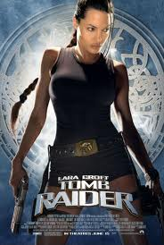

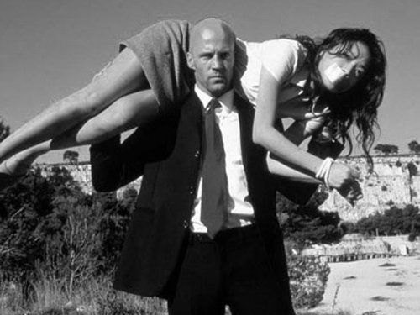

1. How are men represented in these pictures? Annotate the pictures showing what mise-en-scene has been used to represent them a particular way.
2. Why are they conventional male protagonists for an action/adventure film?

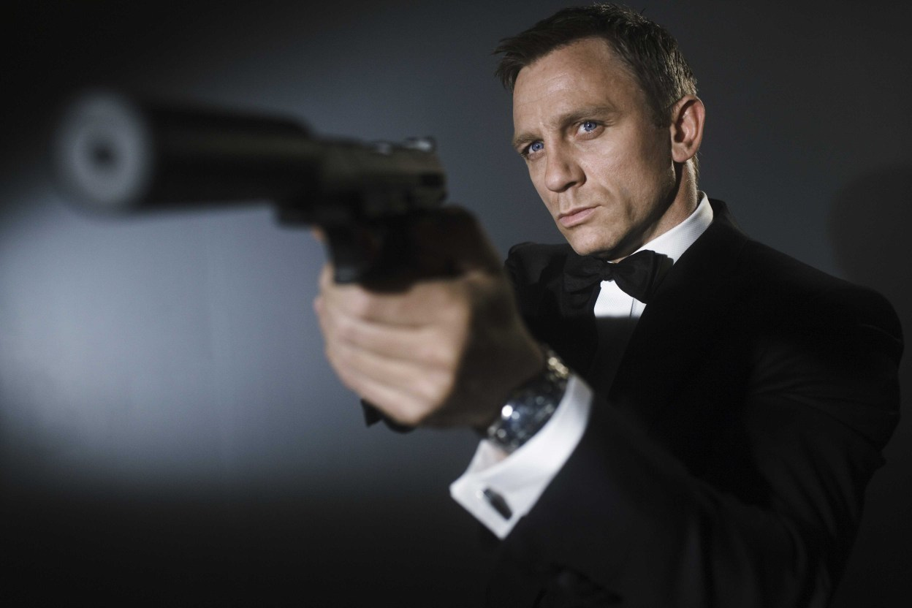

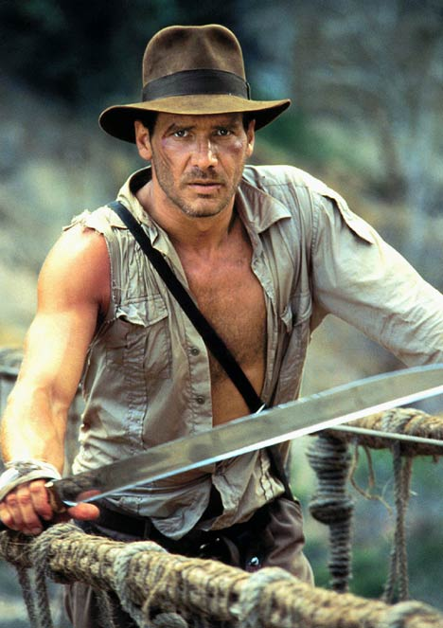

1. How is ethnicity represented in these pictures? Annotate the pictures showing what mise-en-scene has been used to represent them a particular way.
2. Which characters are represented more positively? How do you know from the pictures?

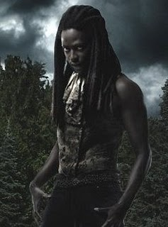

TV Comedy Glossary
Terminology | What it means...
TV Comedy
Institution | A large media corporation or company. For example Channel 4 or the BBC.
Watershed | The watershed is the time before 9pm on television. It is in place to protect younger audience members from offensive material, such as swearing, sex and violence. Any show shown after 9pm is referred to as post-watershed.
Intertextuality | Intertextuality is when one media text refers to another. For example when The Simpsons included a reference to JK Rowling and the Harry Potter books. It is a way to create audience pleasure as the audience would feel clever for noticing the reference.
Audience ‘hook’ | An audience hook is a method used by television channel to encourage the audience to stay watching that channel. For example putting on a popular TV show before another show they want to encourage you to watch.
Universal audience | A universal audience is a wide audience which includes everyone. Everyone will like the product/media text.
Public Service Broadcaster (PSB) | Any terrestrial channel. BBC 1, BBC 2, ITV 1, Channel 4 and Channel 5. These channels must follow particular charters to make the audience happy.
Niche audience | An small and specific target audience. For example teenagers.
Mass audience | A wide audience. For example families.
Stripped schedule | A stripped schedule is the practice of running a television series at the same time daily (or at least on Mondays to Fridays), so that it appears as a strip straight across the weekly schedule.

What is Section B about?
Section B assesses your awareness of audiences & institutions in relation to TV Comedy. In the exam you will be asked two questions in which you should show an understanding of institutions studied and why audiences enjoy watching TV Comedy.
Question 1 – will ask you to explain why particular comedies are shown on particular channels and on particular days/timeslots. You should demonstrate your understanding of BBC and Channel 4 and their differences as institutions. You should also demonstrate your awareness of audience and when they watch television and how this effects the scheduling of programmes.
Remember the comedies we have focused on as a class are:
1. The Royle Family
2. The I.T Crowd

Question 2 - needs you to know about two TV Comedies to illustrate your answer. Typically, the question will ask about what pleasures TV Comedies offer their audiences. You will be expected to not only be able to name pleasures that all comedies offer but pleasures the programmes you’ve chosen offer specifically, depending on their audience. For example a sit-com with a target audience of ‘family’ is going to have different pleasures than a comedy quiz show about politics aimed at ‘adults’.
Before you turn over:
a) List below the different pleasures TV Comedies offer their audiences. Once you have completed the list highlight/underline in different colours which ones The Royle Family offers and which pleasures The I.T Crowd offer. Remember both programmes are sit-coms; therefore they follow sit-com conventions. Try to think of clear examples from the programmes to support your ideas.
For example:
1) Audience superiority – When the audience watch characters make ridiculous mistakes they feel superior to the characters as they know they would not make the same mistakes themselves.

Audience pleasures of TV Comedy Revision
How many did you manage to remember? Read through the list below and again highlight/underline which pleasures The Royle Family offers and which ones The I.T Crowd offer. How many do the two programmes have in common?
- Regular timeslot
- The narrative and problems are always resolved at the end of the programme
- Intertextuality
- Use of celebrities
- Different types of humour
- Relatable characters and situations (so we can also laugh at ourselves/friends)
- Audience escapism
- Audience feels superior to characters as they never learn from their mistakes.
- Easy to watch (30 minutes long and self-contained episodes mean audience can ‘dip’ in and out of series).
- Pleasure gained from resolution at the end of episode
- Social and family issues often used (audience can relate to)
- Themes are easy for audience to understand
- Warm mode of address - everyone can watch and enjoy.
- Familiarity (e.g. Catchphrases)
- Predictability – For example: audiences know character well and know how they will react.
- New variations of the genre create interest
Now for some detail...
Pick two pleasures The Royle Family offers:
a).........................................................................................................................................................................
b).........................................................................................................................................................................
Pick two pleasures The I.T Crowd offers:
a).........................................................................................................................................................................
b).........................................................................................................................................................................
Pick two pleasures both comedies offer:
a).........................................................................................................................................................................
b).........................................................................................................................................................................
Now, using clear examples from episodes studied answer the question: “Discuss in detail how two comedy programmes offer audience pleasures.” Try to take no longer than 20 minutes on your answer.

Institution and Scheduling Revision
Complete the activities below to help you revise information about BBC and Channel 4.
Target audience:

Name 3 rules the BBC have to follow which fit with BBC 3:
1.

2.

3.
Target audience:

Name Channel 4’s 3 core values:
1.

2.

3.

The Royle Family
Scheduled day and time: ____________________________________________________
Channel: ______________________________________
Give three reasons below why you think The Royle Family is scheduled at this time and that channel. Try to give clear examples to support your ideas either about the institution or from the programme.
1. _____________________________________________________________________________________
_____________________________________________________________________________________________________________________________________________________________________________________________________________________________________________________________________
2. _____________________________________________________________________________________
_____________________________________________________________________________________________________________________________________________________________________________________________________________________________________________________________________
3. _____________________________________________________________________________________
_____________________________________________________________________________________________________________________________________________________________________________________________________________________________________________________________________
The I.T Crowd
Scheduled day and time: __________________________________________
Channel: _______________________________________
Give three reasons below why you think The I.T Crowd is scheduled at this time and on that channel. Try to give clear examples to support your ideas either about the institution or from the programme.
1. _____________________________________________________________________________________
_____________________________________________________________________________________________________________________________________________________________________________________________________________________________________________________________________
2. _____________________________________________________________________________________
_____________________________________________________________________________________________________________________________________________________________________________________________________________________________________________________________________
3. _____________________________________________________________________________________
_____________________________________________________________________________________________________________________________________________________________________________________________________________________________________________________________________
Now, using clear examples answer the question: “Pick two TV comedies you have studied. Discuss why they were scheduled:
• On the channels that chose them
• On the days and times they were transmitted.”
Try to take no longer than 20 minutes on your answer.

Practice Exam Questions
Section A – Action/Adventure
FOR THE CLIP WHICH GOES WITH THE QUESTIONS GO TO WWW.YOUTUBE.COM AND THEN SEARCH PIRATES OF THE CARIBBEAN – JACK AND WILL FIGHT SCENE.
1. Explain two ways in which characters and/or events fit the action/adventure genre. [10]
2. Explain how each of the following is used to create effects that fit the action/adventure genre.
- soundtrack
- camera work
- editing
- mise-en-scene [20]
3. Discuss the ways in which men and/or age are represented in the extract. [20]
Section B – TV Comedy
Answer this question using Television and/or Radio Comedy programmes you have studied.

4 Pick two TV or radio comedies you have studied.

(a) Discuss why they were scheduled:
• On the channels that chose them
• On the days and times they were transmitted. [15]

(b) Show how these two programmes offer their audiences different pleasures. [15]

